GEOSPATIAL ANALYSIS OF WATER RESOURCES MANAGEMENT IN DURHAM IN THE LOCAL MUNICIPALITY.
INTRODUCTION
In the world, almost every sector is using Geographical Information System (GIS ) tools to solve problems, predict future changes (Leipnik et al., 1993), monitor performance, and finally provides or presents spatial information as required. .Using Geographical Information System (GIS )one can get to know the actual time situation whereabout, therefore showing how people can be affected in terms of business or even weather change. Technology in GIS is no other different since it uses geographical science with tools in getting to know hence aiding them to attain their goals .GIs application assists its user to understand spatial data and information in maps hence helping them alter maps information bringing changes where required. Geospatial data analysis brings together evaluates and shows the geographical information system (GIS) data and images. This also puts GPS and photographs from satellites in place. Geospatial data analysis includes using data from all kinds of media platforms to come up with data clarity and making it easy to get its rights trends on resources.
On earth, there are more than 326 million trillion particles of water. As it is known, less than 3% of this water is safe and fresh for use. Almost two-thirds of it is in ice caps form. Water is significantly used to produce hydropower through energy harnessing. Water is termed as a renewables source of energy compared to others. In our daily activities, it is very impossible to do without water. Talk of washing, toilet usage drinking we need water for survival. In Canada, there is the National Hydro Network (NHN) that gives geospatial data digitally explaining water features like rivers lakes, and dams.
Because of the nature of spatial data required GIS has been used in modeling water resources. Geospatial analysis has recently risen in water resources data in measuring and observing changes occurring on water resources in general. Using the gis data, geospatial analysis information on water resources can be used to help people take specific steps before certain calamities like drought which is done through prediction and continuous monitoring. Geospatial data analysis taken at a resolution of 8km shows that 63.5% of people in Africa and other continents rely on resources of water that are at the same time available and limited.
For any natural resource to be managed successfully, accurate knowledge and informed decision are required. This is important to enable their usage without exploitation or misuse. Therefore, if the water is well managed with regulation and rules to its utilization put in place then it would be rendered a conflict-free resource. Furthermore, water availability affects 40% of the population global having 70% of disaster-related cases like death. Shortly feeding of people will require much agricultural increase in food production. This means a certain percentage of water withdrawal making it more demanded hence its scarcity. Water is a scarce resource, people's demands increase hence making it a point and source of conflict among communities. From the water resource projection study, in 2025 some people will be residing in a region with little or no water. Water management schemes and regimes are very important to guard water utilization and safety.
It every one wishes to use clean and safe water for all purposes. For instance, in Durham 2018 its Canadian government ensured that every individual is entitled to clean and safe water for drinking. By so doing the government was so sure that this will reduce health issues related to dirty water. Intern this would strengthen its economy and creating opportunities for the same. In addition to safe water, water treatment is a very essential thing for healthy environment maintenance.
As said earlier, water management technology is an essential tool in the water resource management sector. For instance in EUROPE, there a wireless device having a mobile app that utilizes sensors connected to water appliances in urban areas to put together data about water utilization. This device is called (UDSS) Urban Decision Support System. The device is fitted in a manner that the owner will be able to know which appliance is using much water. The owner can know what change is needed to minimize the excess water utilization by that certain appliance (Lena et al 2017).

OBJECTIVES
To find out ways Gis can enable a more efficient water resource management in Durham
To find out the water resource watersheds maps/ satellite images in Durham.
To find out the policies and regulation governing water resources within the Durham city

AREA OF STUDY DESCRIPTION
The study took place in the Durham region which lies on 53.542613 N, 113.494290W.Coordinates.It is a regional municipality in the south of Ontario in Canada. The region is situated East of Toronto and the Municipality of York. Durham makes the eastern endpoint of Greater Toronto. This is a fast-growing region with almost 690000 population and it is viewed that it will reach 1 million people by 2031 showing that it is growing at a very high rate population-wise. Durham has plenty of water supply sources. To the south lies Lake Ontario, East lake Scugog and lastly lake Simcoe to the North. People in this region do farming as indicated by plenty of farmlands. Additionally, these people in the Durham region practice multicultural markets where you can not miss what you want in their marketplace.

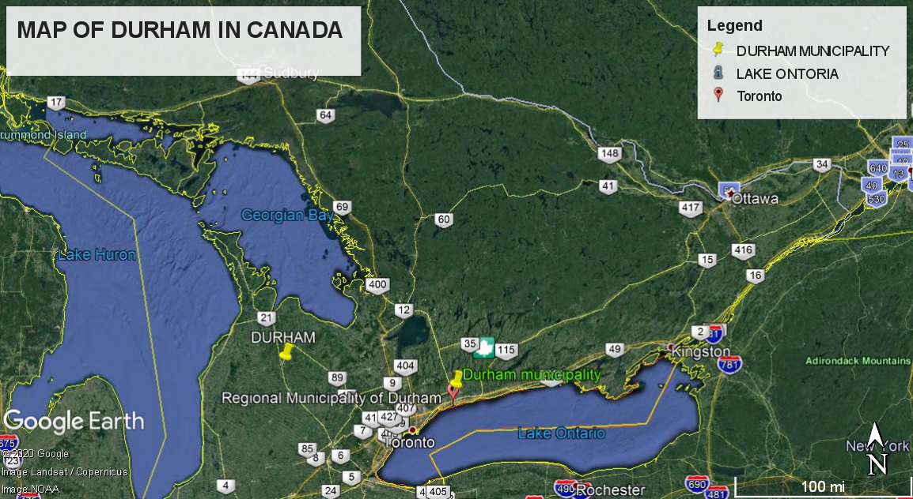
Durham map showing the area where the study took place.

METHODOLOGY FOR SURFACE WATER IN CANADA
In Canada, Gis tools have been used severally in water resource management. The tool is used in documenting, visualization spatial data related to water resources and also in the management sector(Kaden,1993).In surface water hydrology and another water-related field modeling, GIS with or without model has been applied severally. (Lanfear,1992). Modeling surface water shows the impacts it has on running- water in water bodies like dams, canals, or even rivers. Models in run-off waters need vast parameters that show distinct soil types, land use activities which only can be aided by GIS use (Brath et al., 1989). Data input accuracy makes the work accurate. Computer models are used to analyze hydrologic storm runoff water. Watershed characteristics such as length of the channel, area of the watershed can be found by the use of a computer. For example, KEEFER (1991) found out the impact of river mode digitizing error on GIS-based estimated of polygon and length area. Of all the accuracy standards used, a polygon that is GIS-based was the most used without bias. Length of the lines was found to be biased by the use of a standard of digitalizing since were loose. DSS device is a water resource data handling system that is readily available for hydrological prediction models. In GIS a database created using ARC/INFO consisting of all characteristics of water flow and also showing all soil coverage, land use coverage, and others and then stored on different layers of shapefiles in GIS. Overlay of the shapefiles can be mapped. Compilation of different functionalities such, drainage densities, watershed areas, and channel frequencies, can be done by use of GIS. Otherwise, some parameters like stream order and their distances are to found analyzed externally and attached to the shapefiles.
Satellite images downloaded from Geobase ( Geobase surface water program in natural resource in Canada) site of Canadian GIS data were used as secondary data to show the surface water coverage in Durham. It is said that to get final fine results from several modeling accuracies of the area of study data obtain is very necessary. A combination of secondary raster and vector data was also incorporated to get the land cover classes( Shamsi et al. 1991).
To manage water in Canada its government has two main aims. Protecting water resources and promoting wise use and management of the water. To obtain data on water management policies, secondary data downloaded from Geobase was used to get the required police and to date applied ones. Reading from the different journals was also used as a method to find the importance of these policies to surface water management.

RESULTS.
1.A MAP OF WATERSHED IN DURHAM (CANADA) (Hazen and Sawyer 2012)
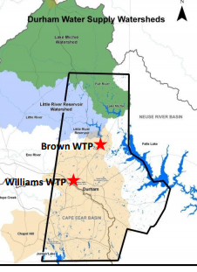

2.POLICIES GOVERNING WATER RESOURCE MANAGEMENT IN CANADA AND THEIR IMPORTANCE TO MANAGING WATER AS A RESOURCE.
In Canada, natural resource together with the environmental sector in 1987 formed ‘federal water policy’
The policy aims to explain to people the importance of using freshwater sustainably and quality sharing in the society, economy, and also in the present environment without forgetting the generation to come needs. Under the Federal Water policy,5 strategies are used to enable attaining its goals fully.
These strategies are,1 price of the water- People from Canada use generally water with low prices due to the subsidies provided by their government. To avoid cases of water misuse, overuse, and also water conflict cases, the government is going to introduce payment for the environmental services( water conservation in that case) which is viewed as a way of keeping water standards high.
2.Leadership based on science. The government in Canada is going to allow more opportunities for developing new technologies(gis application ) that are environmentally compatible. This will involve both private and non-governmental sector, interested partners.
3.Intergrated planning. There is an integrated approach by the Canadian government which is purposed to enable planning and development of water resources. The approach can be applied by all bodies whichever private or non-governmental mainly on a planning scale. We well know that, wherever water as a resource is available, recreational and other water-related water activities arise. Therefore their image gives the government chance to add cooperation planning with learning institutions and other agencies.
4.Legislation, the Canadian government has not yet modernized the planning legislation available so it aims to do so for the federal water policy support.
5. public awareness, The government of Canada is doing much to create awareness among the public to increase and support water resource management and protection. The purpose of this is to give the public a chance to speak their mind on what needs to be done in the water resource sector.

SOURCES OF THE DATA
Canadian Geographical Names (C.G.N)
The Canadian Geographical Names Data Base (C.G.N.D.B) is the national authorized database in Canada by the geographical names. Its aim is to names places and attributes that have been authorized by the Geographical Names Board of Canada (GNBC).
2. GeoGratis
GeoGratis is an app like system given by the Earth Sciences Sector (ESS) of Natural Resources Canada (NRCan) that geospatial data for free and its limitless through the Web browser. The data is important whether when one needs a map to present a geographically, also it is required by an expert that requires vector data overlay. There are over 100 collection groups of geospatial data that go hand in hand with GIS data are grouped in over 100 collections and are compatible with the most popular geographic information systems (GIS) with images derive software.

IMPORTANCE OF GEOSPATIAL ANALYSIS ON WATER RESOURCE MANAGEMENT
It is important for the successful application in other landscapes as said by Mackay and Band (1998). By use of geospatial data, one can know the relationship of recent and coming usage, source, and pollution in these water resources. Furthermore, the presence of vast data acquired through increased spatial knowledge sharing has been used to develop (SDI) Spatial Data information. Mining of geospatial data can be used to show the unrevealed issues which can bring crisis such as pollution, drought, famine, and others and the measures to be taken on them.

EMERGING QUESTION ON GEOSPATIAL ANALYSIS of WATER RESOURCES.
problems may arise if limitations in models forgot when GIS-based modeling applications are developed while upcoming users are unable to recognize the effects of the disadvantages to the report.

From the way modeling of fieldwork is becoming easy. validation, calibration, and other might be forgotten. Therefore it is advisable that future research to concentrate on these kinds of models.
According to Wilkinson (1996), GIS needs new ways of analyzing geospatial data this is due to the increasing geographical data. Much knowledge is required to improve how environmental data are collected, stored, or even turned into useful information.
There is a gap to know which of the functionality /algorithms eg FD8 best work in different data sources.s contours, GPS data set, and others( Wilson 1999). It will be of prudence if a method that mimics the action on actual runoff is developed. Since most of the data used in water resource management are internally oriented from GIS, much more documentation of the result of using a certain method is more important in near future.

DATABASE DEVELOPMENT
In every GIS, there are certain types of data. These include raster data and vector data as outlined by most GIS books. These two types of data are purposed in representing the spatial features to the real form of the world, that is they appear as they are in a real situation. According to McDonnell (1998), the real representation of these features to the real world is grouped into entities and fields.
1.Raster data represents features in square cells with several values intact to each cell. Below is an example of raster data with low and high resolutions. Each raster grid format contains a huge amount of information. Each cell covers a specific area in the real world which is called spatial resolution.
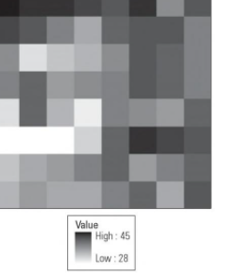
A raster image example
2. Vector data is made of points (x and y-coordinates), lines, and area polygons. Point data represents nonadjacent features and data points. Examples of these features include schools and points of interest in geographical location. Line data is also called arc which shows linear features like rivers, streets, and others. This feature has only one dimension and the only length can be measured. These features have start and endpoints. To differentiate these line features, solid or dotted lines with different colors and line thickness are used. Polygon data are used to show the boundary of water basins or even national parks. Therefore, to make a difference between these features, color and pattern are commonly used. Importantly, point and line data help reduce clustering hence easing data location. Below is an example of a point as vector data.
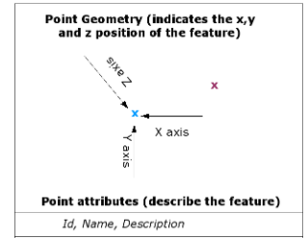

The x in blue for example can be a mango tree out the offices
The x in purple could be a CCTV post on the company entry
Here is a vector polygon data example

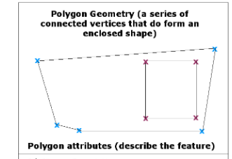
The outer polygon could be a homestead fence while the small polygon could be FISH POND.

PROCESS OF DATA MINING

F. Karimipour et al. / Journal of Environmental Informatics 5 (2) 61 - 72 (2005)
TRANSFORMATION
SELECTED DATA
CLEANED DATA
STORED DATA
EXTRACTED INFORMATION

PREPROCESSING
INTERPRETENTI INFORMATION
SELECTION
CLEANING

According to Miller and Han 2001 data mining process involves several stages which include, storage, cleaning, selecting, reducing, extracting information, interpretation, and reporting. Cleaning is done to free the data from errors since most are collected as been raw from the field. Data selection involves collecting the data and recording it in a database so that it can be used in operation properly for analysis to provide fine results. Reducing data is like reselecting the same data into reduced point records and merged properly. Extraction stage, the data are studied to come up with patterns that form the main stage. Finally, interpretation of the data involves evaluating the parameters for use.

CONCLUSIO

